Parents’ Guide to Student Success in *Mathematics*

*Kindergarten*

**Why Are Academic Standards Important?**

Academic standards are important because they help ensure that all students, no matter where they live, are prepared for success in college and the workforce. Standards provide an important first step — a clear roadmap for learning for teachers, parents, and students. Having clearly defined goals helps families and teachers work together to ensure that students succeed. They also will help your child develop critical thinking skills that will prepare him or her for college and career.

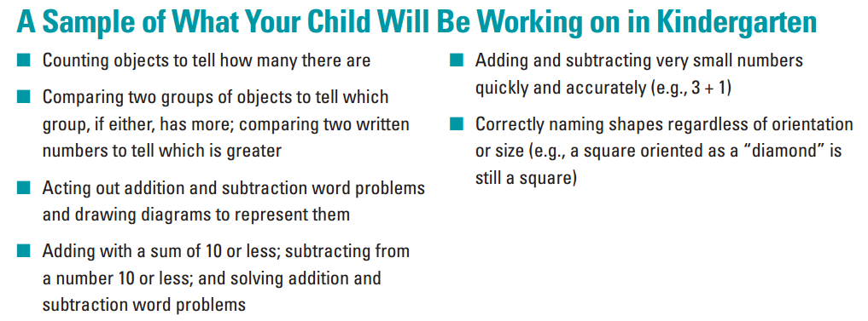

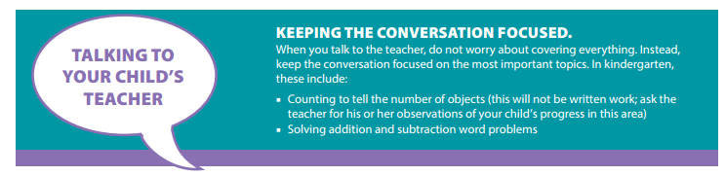

**Help Your Child Learn at Home**

Try to create a quiet place for your child to study, and carve out time every day when your child can concentrate. You should also try to sit down with your child at least once a week for 15 to 30 minutes while he or she works on homework. This will keep you informed about what your child is working on, and it will help you be the first to know if your child needs help with specific topics. Additionally, here are some activities you can do with your child to support learning at home:

* Ask your child questions that require counting as many as 20 things. For example, ask, “How many books do you have about wild animals?”
* Ask your child questions that require comparing numbers. “Who is wearing more bracelets, you or your sister?” (Your child might use matching or counting to find the answer.)

Resource: <http://www.pta.org/parents/>

**Kindergarten**

Nine Week Checkpoints for Parents and Students



|  |  |
| --- | --- |
| **First Nine Weeks** | **Second Nine Weeks** |
| *Helpful websites to help students master the first and second nine week concepts:*  [*https://www.khanacademy.org/commoncore/grade-K-CC*](https://www.khanacademy.org/commoncore/grade-K-CC)  [*https://www.khanacademy.org/commoncore/grade-K-NBT*](https://www.khanacademy.org/commoncore/grade-K-NBT) | |
| *Students should know and be able to:*   * Count to 100 by ones and by tens * Count forward and backwards from a given number * Read/write numbers to represent the number of objects using numerals from 0 to 20 * Classify objects and count the number of objects in each category. * Put together and take apart numbers 11-19 using tens and ones | *Students should know and be able to:*   * Compare groups of objects using words “greater than,” “less than,” or “equal to” * Compare numbers 1-10 written as numerals * Describe and compare objects using length, width, weight, and height |
| **Third Nine Weeks** | **Fourth Nine Weeks** |
| *Helpful websites to help students master the third and fourth nine week concepts:*  [*https://www.khanacademy.org/commoncore/grade-K-OA*](https://www.khanacademy.org/commoncore/grade-K-OA)  [*https://www.khanacademy.org/commoncore/grade-K-G*](https://www.khanacademy.org/commoncore/grade-K-G)  [*https://www.khanacademy.org/commoncore/grade-K-MD*](https://www.khanacademy.org/commoncore/grade-K-MD) | |
| *Students should know and be able to:*   * Show addition and subtraction in many ways (with objects, fingers, drawings, mental math) * When given any number from 1-9, show the number needed to make ten * Break apart numbers less than or equal to 10 * **Fluently add and subtract within 5 using mental math** | *Students should know and be able to:*   * Identify and compare 2 and 3 dimensional shapes (such as squares, circles, triangles, rectangles, hexagons, cubes, cones, cylinders, and spheres) * Describe objects in the environment using names of shapes and describe the positions of these objects using terms such as above, below, beside, in front of, behind, and next to * Compare shapes by their attributes * Model shapes in the world by building shapes from components (i.e. sticks and clay balls) * Make shapes from smaller shapes |